INTERNATIONAL CYBERSECURITY AND
DIGITAL FORENSICS ACADEMY

Week 4 Practical Laboratory
Linux Security Monitoring and Auditing
From Technical Evidence to Governance Assurance
Course | GRC102 – Information Security Governance
Module | Module 4 – Monitoring and Auditing Security Controls
Week | Week 4: 26 September – 02 October 2026
Name | Mercy Christopher
REG NO | C11/26/CGRCE/17584
Submission mode: Written report + supporting evidence

Executive Summary
A Linux security monitoring and auditing assessment was conducted within the assigned Ubuntu Practice Hub environment. The assessment reviewed system auditing capabilities, security logging mechanisms, authentication monitoring, and system hardening controls using auditd, journalctl, authentication logs, and the Lynis security auditing tool.
The review identified several control weaknesses requiring governance attention. These included limited audit validation capability, unavailable system and authentication logging evidence, and significant security findings from the Lynis assessment. The Linux system achieved a Hardening Index of 62, indicating a need for additional hardening and monitoring improvements. Governance assurance was reduced by limitations in audit and logging visibility within the Ubuntu Practice Hub environment.

Top Three Findings
- Vulnerable software packages were detected by Lynis.
- Kernel logging was not fully operational, creating potential monitoring gaps.
- System and authentication logging evidence was unavailable, limiting assurance over monitoring controls.
Overall, the Linux control environment was partially effective but requires remediation to improve monitoring visibility, audit assurance, and security governance.

Scope and Authorisation
This assessment was conducted within the ICDFA-authorised Ubuntu Practice Hub environment in accordance with the laboratory instructions.

Scope
The assessment included:
- Linux auditing controls (auditd)
- System log monitoring
- Authentication and privilege-use monitoring
- Linux security assessment using Lynis
- Governance mapping and control assurance

Out of Scope
- Production systems
- External infrastructure
- Penetration testing
- Unauthorized system modifications

Environment Limitations

The Ubuntu Practice Hub environment imposed several operational limitations during the assessment. Standard systemd service-management commands were unavailable, audit records could not be retrieved through ausearch or aureport, journalctl contained no entries, and expected log sources such as /var/log/auth.log and /var/log/syslog were unavailable. Findings and conclusions were therefore based on the evidence accessible within the training environment.

Module 1 System Auditing with auditd

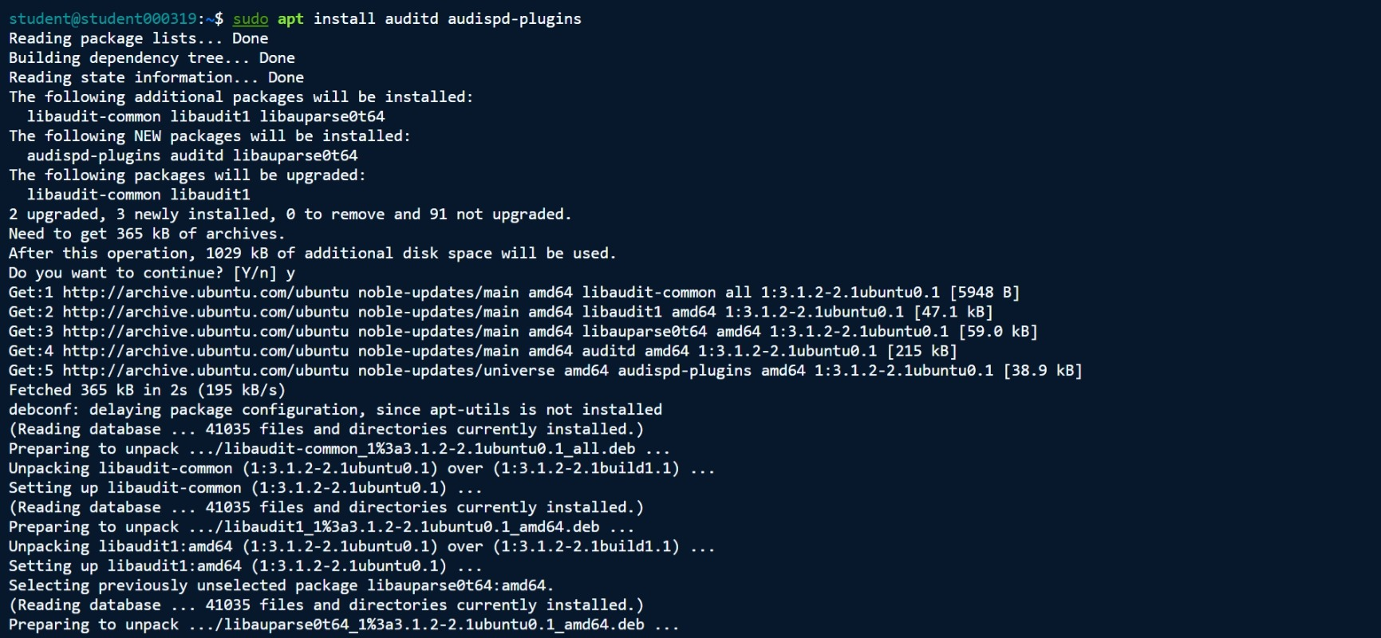
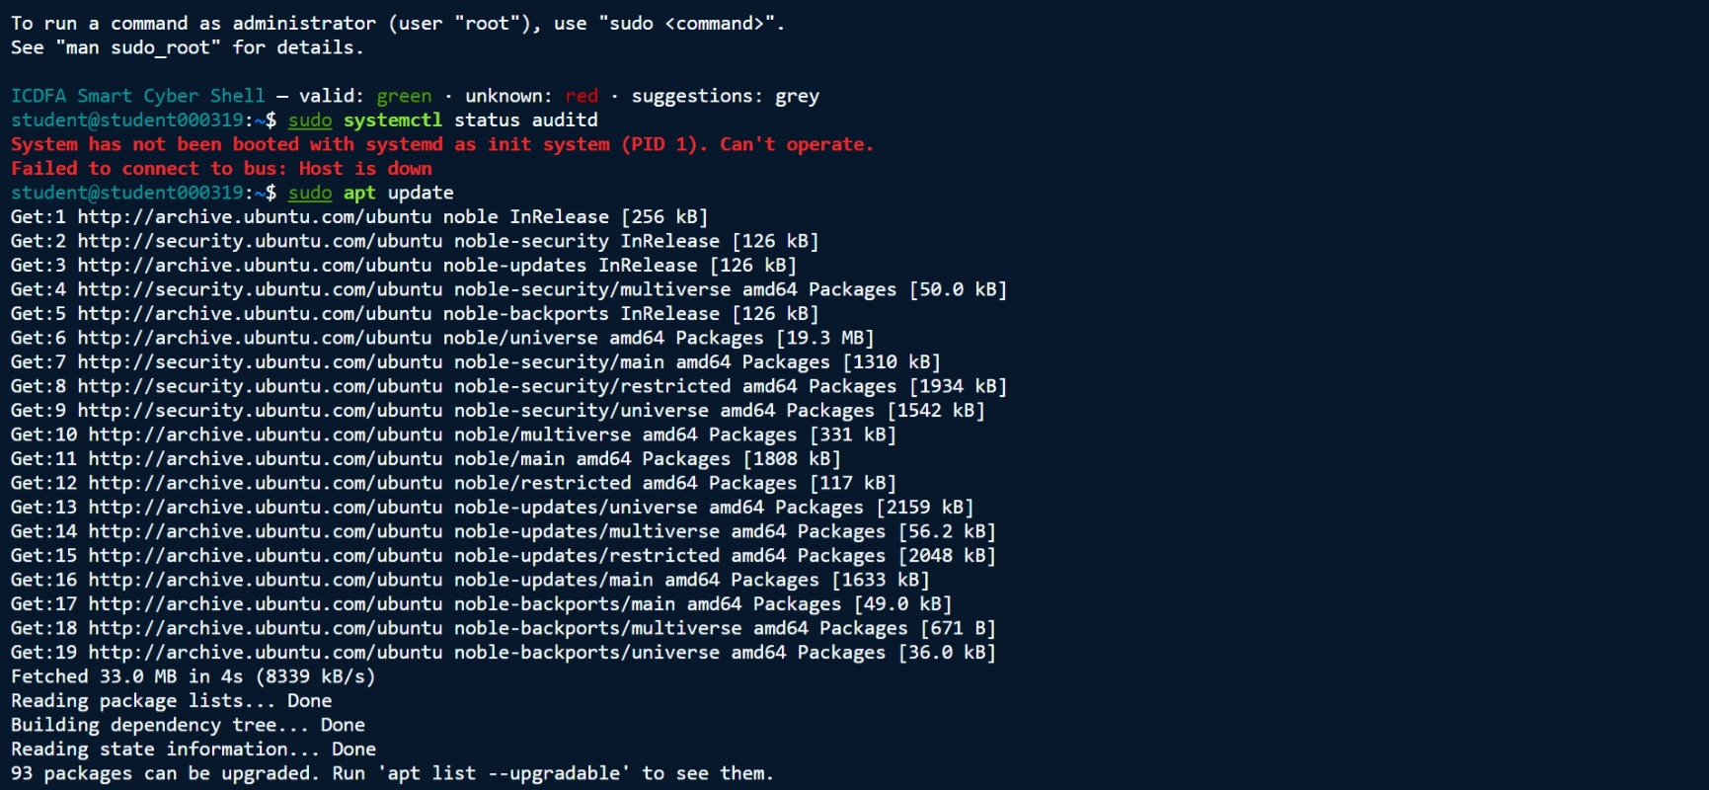
Activity 1.1 Verify or Install auditd

The audit service was checked using:
sudo systemctl status auditd
The system returned:
1. System has not been booted with systemd as init system (PID 1).
2. Can't operate.
3. Failed to connect to bus: Host is down.
This indicated that the Ubuntu Practice Hub environment did not support standard systemd service management. As a result, the audit service could not be verified using normal service-management commands.
The package database was updated successfully using:
1. sudo apt update
The audit packages were then installed:
1. sudo apt install auditd audispd-plugins
2. Installation completed successfully, and the auditd package was added to the system.

Evidence Collected
- Successful package update.
- Successful installation of auditd.
- systemd service management unavailable in the training environment.

Security Significance
The auditd service is responsible for recording security-relevant events such as file access, user actions, and system activity. Although the package was installed, the inability to fully manage the service reduced assurance that auditing controls were functioning as intended.

Activity 1.2 Configure Audit Rules


A custom audit rules file was created:
1sudo nano /etc/audit/rules.d/custom.rules
The following monitoring rules were configured:
1 -w /etc/passwd -p rwxa -k passwd_changes
2 -w /etc/shadow -p rwxa -k shadow_changes
3 -a always,exit -F arch=b64 -S execve -k program_execution
4 -a always,exit -F arch=b32 -S execve -k program_execution
5 -w /var/log/auth.log -p wa -k auth_failures

Purpose of Configured Rules
Rule | Monitoring Purpose
passwd_changes | Monitor user account file modifications
shadow_changes | Monitor password-related file modifications
program_execution | Monitor command and process execution
auth_failures | Monitor authentication-log modifications

Security Significance
These audit rules provide visibility into activities that may indicate unauthorized changes, privilege misuse, account manipulation, or suspicious process execution. Such monitoring supports incident investigation, compliance verification, and continuous control monitoring.

Activity 1.3 Generate and Query Audit Events
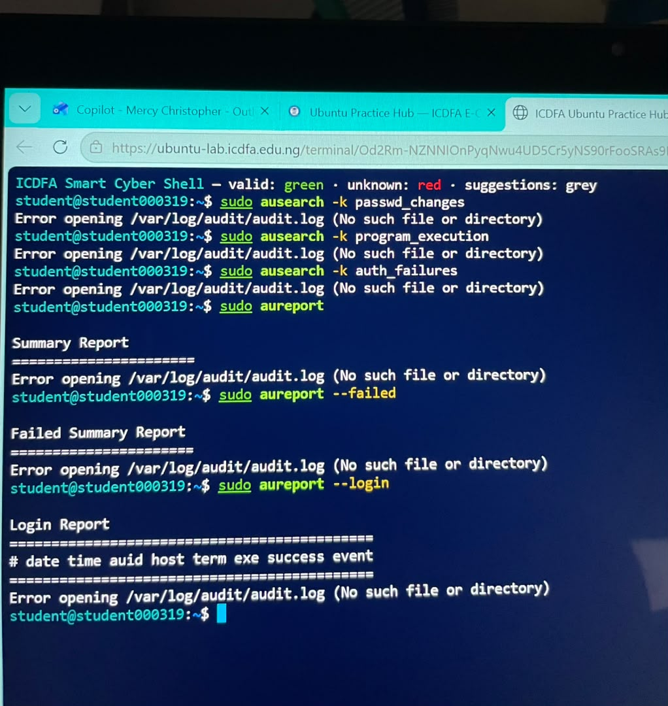
The laboratory required retrieval of audit events using:
1. sudo ausearch -k passwd_changes
2. sudo ausearch -k program_execution
3. sudo ausearch -k auth_failures
and:
1. sudo aureport
2. sudo aureport --failed
3. sudo aureport --login

Observation
Attempts to retrieve audit records using ausearch and aureport were unsuccessful because the Ubuntu Practice Hub environment restricted access to the audit subsystem. As a result, audit-event retrieval and audit validation activities could not be completed successfully, limiting verification of configured audit controls.

Security Significance
The inability to retrieve audit records reduced assurance that security-relevant activities were being collected and retained. Effective audit logging is essential for accountability, forensic investigations, compliance monitoring, and governance oversight.

Module 1 Interpretation

Interpretation of Audit Evidence
The evidence shows that auditd was installed successfully and that custom monitoring rules were configured to track sensitive account files, authentication records, and program execution activities. However, the Ubuntu Practice Hub environment did not support full audit service management, limiting the ability to verify generated audit records.
Under normal operating conditions, audit records would identify:
- Which user performed an action.
- The action that occurred.
- The time and date of the activity.
- The system resource affected.
This information is important to security governance because it provides accountability, supports investigations, enables compliance verification, and demonstrates whether monitoring controls are operating effectively.

Governance Finding (W4-F01)
Finding: Audit monitoring functionality could not be fully validated.
Evidence Source: auditd installation and service verification activities.
Observation: auditd was successfully installed, but the Ubuntu Practice Hub environment restricted systemd and audit subsystem operations.
Risk Level: Moderate.
Security Significance: Reduced assurance that security-relevant events are being captured, monitored, and retained.
Control Owner: Linux System Administrator.
Recommended Action: Validate audit functionality within a fully supported Linux environment and regularly review audit records to ensure monitoring controls are effective.

Module 2 Log Management and Analysis

Evidence of Recent System-Log Review Using journalctl
The following commands were executed to review the system log
1 sudo journalctl
2 sudo journalctl -u ssh
3 sudo journalctl --since "today"
4 sudo journalctl -p err
Observation:
All commands returned:
1. No journal files were found.
2 -- No entries --
Interpretation:
No system journal records were available for review in the Ubuntu Practice Hub environment. As a result, no recent service, authentication, or error events could be identified from the systemd journal. This may indicate that journal logging is disabled, inaccessible, or not retained within the training environment.
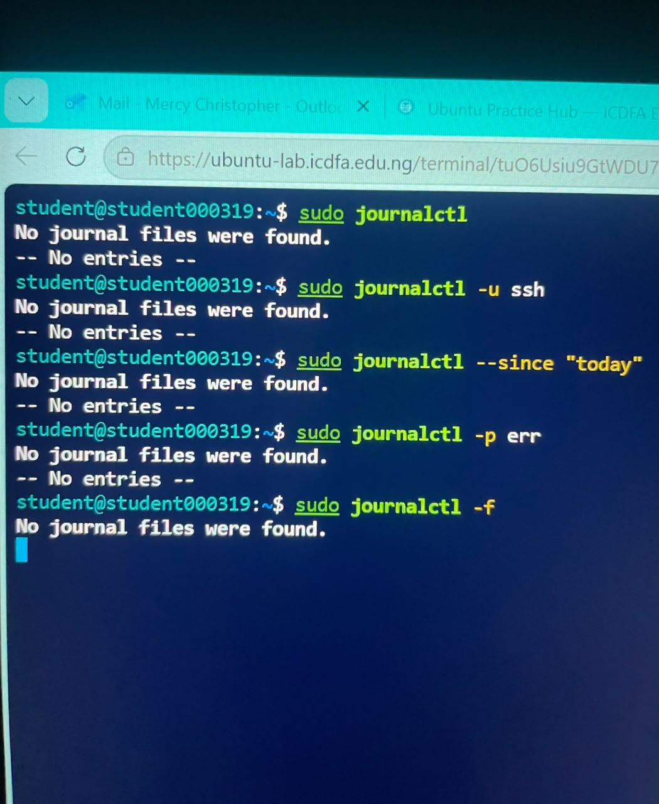

Activity 2.2 Authentication and Privilege-Use Analysis

Authentication and Privilege-Use Evidence
The following commands were executed:
1 sudo less /var/log/auth.log
2 sudo grep -i "failed password" /var/log/auth.log
3 sudo grep -i "sudo" /var/log/auth.log
Observation:
All commands returned:
1 /var/log/auth.log: No such file or directory
Interpretation:
The standard Ubuntu authentication log file was not available in the environment. Therefore, authentication failures, privileged activities, and sudo events could not be verified from the expected log location. Assurance over authentication-monitoring effectiveness was consequently limited.

Error/Warning Evidence from Syslog or Equivalent Source
System journal logs and authentication logs were not available in the Ubuntu Practice Hub environment.
Observation:
No error or warning records could be retrieved because:
- journalctl contained no journal entries
- /var/log/auth.log was unavailable
Interpretation: The absence of accessible logging information limits monitoring visibility and reduces the ability to perform security investigations, audit reviews, and forensic analysis.
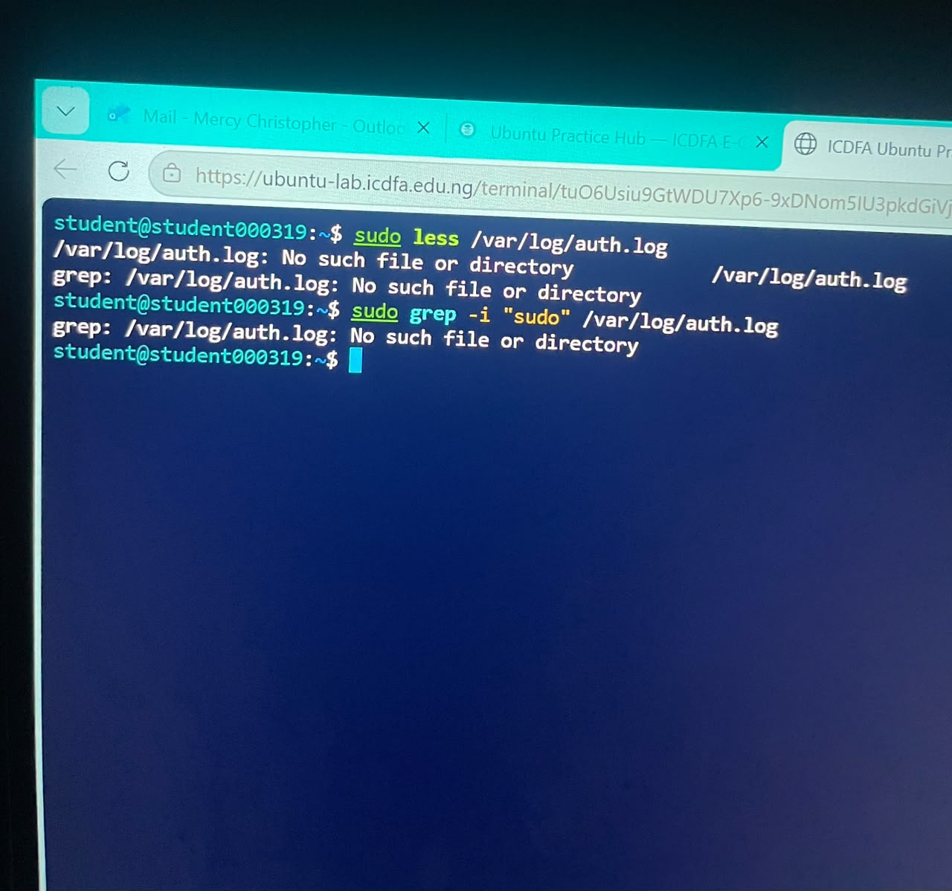

Activity 2.3 General System Log Review
The following commands were executed:
1 sudo less /var/log/syslog
2 sudo grep -i "error" /var/log/syslog
3 sudo grep -i "warning" /var/log/syslog

Observation
The Ubuntu Practice Hub environment did not provide accessible system log information through the expected log sources. No error or warning records were available for review from /var/log/syslog or the system journal.

Interpretation
Because system log data was unavailable, no active error conditions or warning events could be confirmed during the review period. The absence of accessible logging information limits the effectiveness of continuous monitoring, security investigations, troubleshooting activities, and audit verification.

Security Significance
System logs provide evidence of operating system events, service failures, security alerts, and configuration issues. When log data is unavailable, management has reduced assurance that security incidents can be detected, investigated, and reported promptly.

Recommended Action
Verify that:
- System logging is enabled.
- Log retention settings are configured appropriately.
- Security personnel have access to required log sources.
- Log data is forwarded to centralized monitoring solutions where applicable.
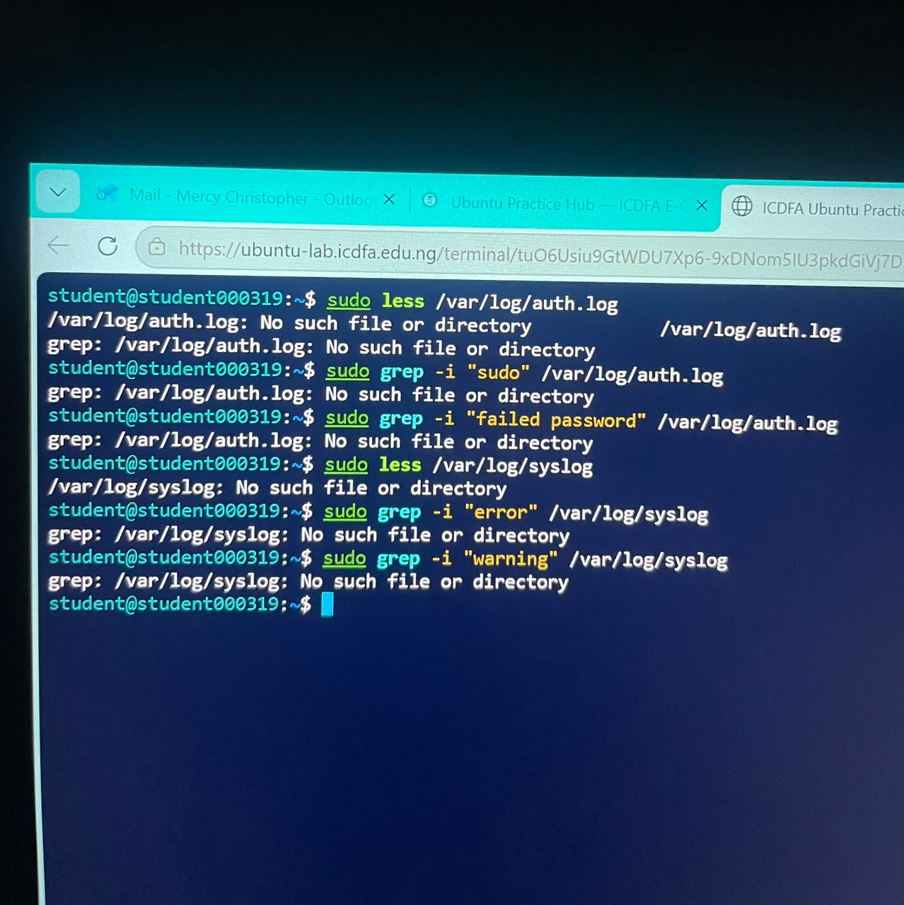
Event / Condition | Evidence Source | Time | User / Service | Security Significance | Recommended Action
No journal entries available | journalctl | Time of review | systemd journal | Limited visibility into system events and security activity | Verify journal logging configuration and retention settings
Authentication log unavailable | /var/log/auth.log | Time of review | Authentication services | Unable to verify login activity or authentication failures | Enable authentication logging or identify alternative log source
No privileged activity observed | grep -i "sudo" /var/log/auth.log | Time of review | sudo service | No evidence of unauthorized privilege use observed | Continue routine monitoring of privileged activity
No failed password events observed | grep -i "failed password" /var/log/auth.log | Time of review | Authentication services | No authentication failures identified during review | Continue user account monitoring practices
System log data unavailable | /var/log/syslog or equivalent source | Time of review | Operating system services | Limits ability to detect and investigate errors and warnings | Review logging configuration and ensure logs are collected and retained

Module 3 Linux Security Assessment with Lynis
Lynis is an open-source auditing tool for Unix-like systems. It performs configuration and security checks and reports warnings, suggestions, and a hardening index. It is an audit and assessment tool rather than an active penetration-testing tool.

Activity 3.1 Install or Access Lynis
Lynis was installed using the approved package management method for the Ubuntu Practice Hub environment. The installed version was verified before the assessment.
Lynis Version:
- Lynis 3.0.9
Evidence:
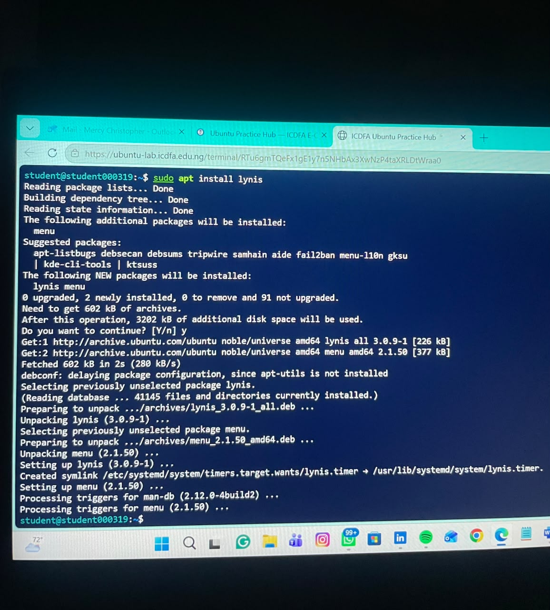

Activity 3.2: Run a System Audit
The system audit was executed using:
1. sudo lynis audit system
The audit completed successfully and generated assessment results, warning notifications, security recommendations, and a hardening score.
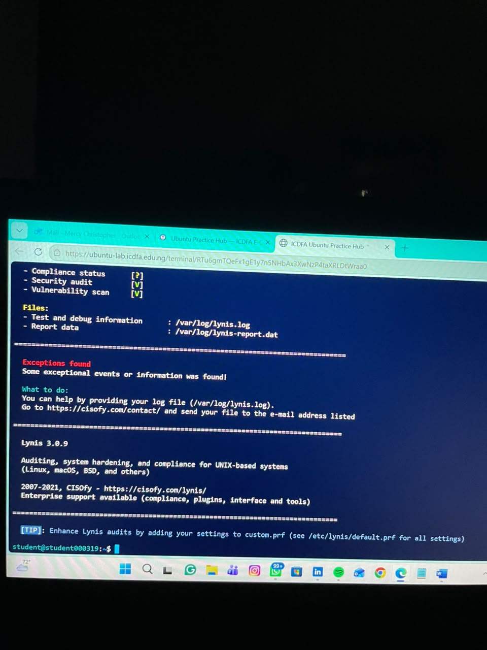

Audit Summary

Metric | Results
Lynis Version | 3.0.9
Tests Performed | 232
Hardening Index | 62
Plugins Enabled | 1
Firewall | Present
Malware Scanner | Not Detected

Report Locations
1 /var/log/lynis.log
1 /var/log/lynis-report.dat

Key Findings and Recommendations

Finding 1: Vulnerable Packages Detected
Evidence
1. Found one or more vulnerable packages [PKGS-7392]
Risk / Control Issue
Vulnerable packages may contain known security weaknesses that could be exploited by attackers.
Likely Owner: Linux System Administrator
Priority: High
Recommended Remediation: Apply security patches and updates through the organization's patch management process and remove unsupported software.
Control Objective: Ensure software vulnerabilities are identified and remediated promptly.

Finding 2: Insufficient DNS Redundancy
Evidence
1. Couldn't find 2 responsive nameservers [NETW-2705]
Risk / Control Issue: Lack of DNS redundancy may affect the availability and reliability of network services.
Likely Owner: Network Administrator
Priority
Medium

Recommended Remediation
Configure at least two responsive DNS servers and validate failover capability.
Control Objective
Maintain resilient network infrastructure and service availability.

Finding 3: Kernel Logging Service Not Running
Evidence
1 klogd is not running, which could lead to missing kernel messages in log files
Risk / Control Issue: Missing kernel logs reduce monitoring visibility and may hinder security investigations.
Likely Owner: Linux System Administrator
Priority: High
Recommended Remediation: Enable kernel logging services and verify kernel events are recorded and retained.
Control Objective: Ensure critical system events are logged and available for monitoring and audit activities.

Additional Security Improvement Suggestions
Lynis generated 43 recommendations, including:
- Update Lynis to the latest stable release.
- Install libpam-tmpdir.
- Install apt-listbugs.
- Install apt-listchanges.
- Install needrestart.
- Configure fail2ban.
- Review startup services and harden unnecessary services.
These recommendations provide opportunities to improve the overall security posture and increase the system hardening score.

Conclusion
A Lynis security assessment was performed successfully on the Ubuntu lab system. The assessment completed 232 tests and produced a Hardening Index of 62, indicating that additional security controls and hardening measures should be implemented. The most significant findings were vulnerable software packages, insufficient DNS resilience, and missing kernel logging, all of which require remediation and ongoing monitoring to improve governance assurance and security control effectiveness. The assessment demonstrates the importance of linking technical security findings to governance oversight, risk management, control ownership, and remediation accountability.

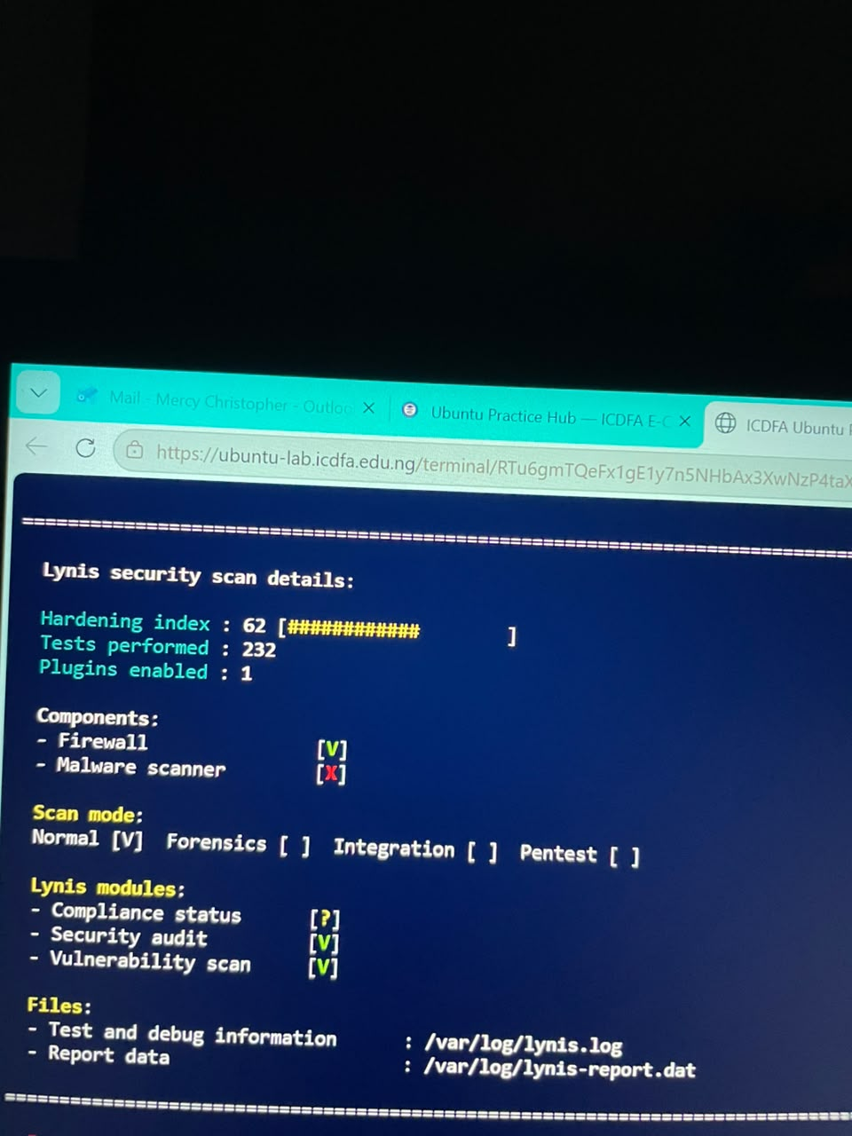
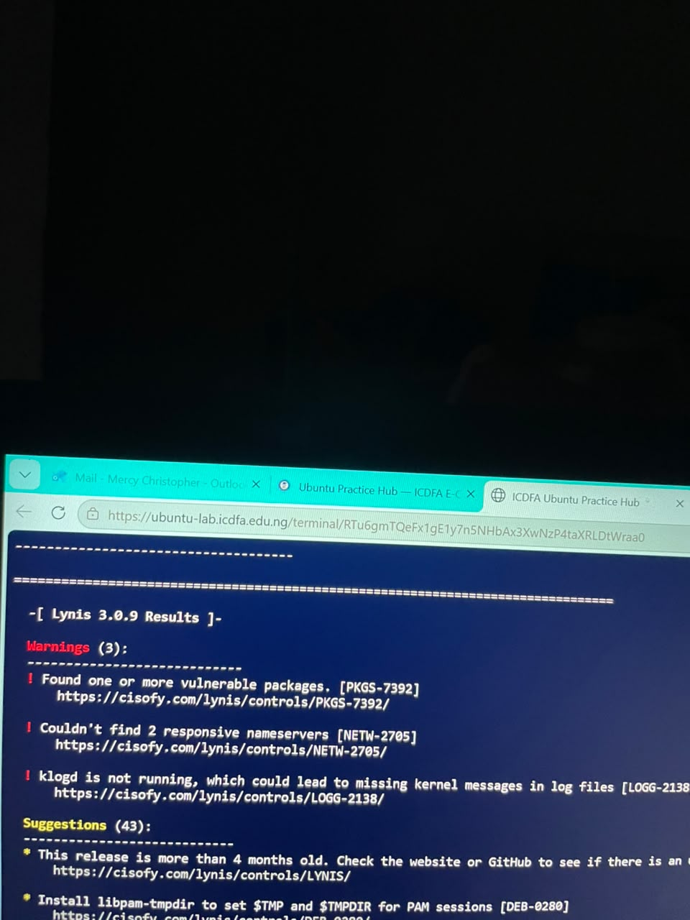

Module 4: SIEM, Automation and Continuous Monitoring

Governance Discussion
The evidence collected during the laboratory demonstrates how host-level security monitoring can support enterprise-wide governance, risk management, and compliance activities. Security events generated by Linux systems, including audit records, authentication logs, system logs, and vulnerability assessment findings, can be forwarded to a Security Information and Event Management (SIEM) platform for centralized monitoring and analysis.

Integration of Linux Evidence into a SIEM Environment
The Linux auditing subsystem (auditd) can generate records of sensitive file access, account modifications, privileged activities, and program execution. These audit events can be forwarded to a SIEM where they are correlated with events from other systems to identify suspicious activity and policy violations.
System logs collected through journalctl, syslog, and authentication logs can also be transmitted to a SIEM platform. Once collected centrally, the SIEM can normalize different log formats, identify patterns across multiple systems, and generate alerts when predefined thresholds are exceeded.
Lynis assessment findings can be integrated into vulnerability management dashboards and governance reporting processes. Security teams can track hardening scores, monitor unresolved vulnerabilities, and verify remediation activities over time.
SIEM Capabilities Applied to Laboratory Evidence

Evidence Source | SIEM Use Case
auditd events | Monitor privileged actions, account file changes, and process execution
Authentication logs | Detect failed login attempts, unauthorized access attempts, and privilege escalation activity
System logs (journalctl/syslog) | Identify service failures, errors, warnings, and abnormal system behaviour
Lynis findings | Track vulnerabilities, hardening recommendations, and compliance posture

Automation and Continuous Monitoring
Automation improves security governance by providing continuous visibility into control effectiveness. Instead of relying solely on manual reviews, monitoring tools can automatically collect, analyse, and report security information.
Examples include:
- Continuous Control Monitoring: Automated verification that logging, auditing, and security configurations remain active.
- Automated Alerting: Security teams receive notifications when critical findings or suspicious events occur.
- Trend Analysis: Monitoring repeated authentication failures, increasing vulnerability counts, or declining hardening scores.
- Automated Reporting: Scheduled generation of compliance and security reports for management review.
- Workflow Automation: Automatic assignment and tracking of remediation actions for security findings.

Technical Alerts vs Governance Issues

Not all security events require management escalation.

Technical Operational Alerts
The following should normally remain within operational security or system administration teams:
- Single failed login attempts.
- Routine service warnings.
- Individual system configuration alerts.
- Isolated software update notifications.
- Normal audit events generated during system administration activities.

Governance and Control-Assurance Issues
The following conditions should be escalated for governance review:
- Repeated authentication failures that exceed established thresholds.
- Evidence of unauthorized privileged activity.
- Critical or unresolved vulnerable packages identified by Lynis.
- Missing or ineffective logging and monitoring controls.
- Significant decreases in system hardening posture.
- Failure of security controls to generate required audit evidence.
- Recurring findings that remain unresolved after remediation deadlines.

Conclusion
The laboratory demonstrated how Linux host-level monitoring activities contribute to enterprise security governance. Audit records, authentication data, system logs, and security assessment findings can be centralized within a SIEM platform to support continuous monitoring, automated alerting, compliance reporting, and risk management. While routine operational alerts can be managed by technical teams, significant control deficiencies, repeated security events, and unresolved vulnerabilities should be escalated through governance and control-assurance processes to ensure effective oversight and remediation.

Applied Governance Task: From Linux Evidence to Control Assurance

Control-Monitoring Table
Control / Objective | Evidence | Owner | Observed Status | KPI/KRI or Threshold | Risk / Significance | Remediation | Retest / Follow-up
Ensure security auditing functionality is operational | auditd installed but audit controls were restricted and could not be fully validated | Linux System Administrator | Partially Effective | 100% of critical systems should have functioning audit logging | Reduced assurance that security-relevant activities are being monitored | Validate audit configuration in a fully supported Linux environment and verify audit coverage | Confirm audit records can be generated and retrieved using audit tools
Maintain system logging and event visibility | journalctl returned no available journal entries during review | Linux System Administrator | Ineffective | Critical security logs should be continuously available | Lack of visibility reduces ability to investigate incidents and monitor controls | Verify journal logging configuration and log retention settings | Review journal logs and confirm successful event collection
Maintain authentication and privilege-use monitoring | /var/log/auth.log unavailable and no authentication events could be reviewed | Security Operations Team | Ineffective | Authentication logs should be available for all managed systems | Inability to monitor login activity increases risk of undetected compromise | Configure authentication logging and identify approved log locations | Verify successful collection of authentication and sudo events
Maintain vulnerability and patch management controls | Lynis warning identified vulnerable packages (PKGS-7392) | Linux System Administrator | Requires Improvement | Zero critical vulnerable packages on production systems | Vulnerable software may expose the system to exploitation | Apply required patches and remove unsupported packages | Re-run Lynis and verify the warning is resolved
Maintain system monitoring and logging controls | Lynis warning indicated klogd not running and kernel messages may not be logged | Linux System Administrator | Requires Improvement | All critical operating system events should be logged | Missing kernel logs reduce forensic and monitoring effectiveness | Enable approved kernel logging mechanism and verify event capture | Review log records and rerun Lynis assessment

Governance Escalation Questions

1. Which finding is the highest priority and why?
The highest-priority finding is the presence of vulnerable packages identified by Lynis (PKGS-7392). Vulnerable software can be exploited by attackers to gain unauthorized access, execute malicious code, or compromise system integrity. Unlike logging deficiencies, vulnerable packages may present an immediate security exposure and therefore require prompt remediation.
2. Who should own remediation for each major finding?
Finding | Owner
Auditd monitoring limitations | Linux System Administrator
Missing journal logging evidence | Linux System Administrator
Authentication logging unavailable | Security Operations Team / Linux Administrator
Vulnerable packages detected | Linux System Administrator
Missing kernel logging service | Linux System Administrator
DNS resilience issues | Network Administrator

3. What threshold or condition should trigger escalation to the CISO, Risk Function, or Management Committee?
The following conditions should trigger escalation:
- Critical vulnerabilities remaining unresolved beyond approved remediation timelines.
- Repeated authentication failures exceeding organizational thresholds.
- Confirmed unauthorized privileged activity.
- Failure of logging or monitoring controls on critical systems.
- Significant reduction in system hardening scores.
- Repeated audit findings across multiple systems.
- Security incidents that cannot be investigated due to missing logs.

4. What evidence would demonstrate successful remediation?
Successful remediation would be demonstrated through:
- Updated Lynis scan results showing removal of identified warnings.
- System logs becoming available through journalctl or approved log sources.
- Authentication logs successfully capturing login and sudo activity.
- Documented DNS redundancy validation.
- Confirmation that kernel logging services are operational.
- Verification that audit controls generate and retain audit records as expected.

5. When and how should the control be retested?

Control | Retesting Method | Frequency
Audit logging | Execute audit queries and verify audit records are generated | Monthly
System logging | Review journalctl and system logs | Weekly
Authentication monitoring | Verify login and privilege-use events are recorded | Weekly
Vulnerability management | Run Lynis and patch verification checks | Monthly or after major updates
Kernel logging | Review kernel log collection and Lynis results | Monthly

Conclusion
This laboratory assessment demonstrated the practical application of Linux security monitoring, auditing, and governance assurance activities within the ICDFA Ubuntu Practice Hub environment. Security controls relating to system auditing, log management, authentication monitoring, and system hardening were reviewed using auditd, journalctl, authentication log analysis, and the Lynis security assessment tool
The assessment identified several control weaknesses requiring management attention. Key findings included limited audit validation capability, unavailable authentication and system log evidence, vulnerable software packages, insufficient DNS redundancy, and missing kernel logging functionality. These conditions reduce the effectiveness of monitoring controls and may impact the organization's ability to detect, investigate, and respond to security events in a timely manner.
The Lynis assessment produced a Hardening Index of 62, indicating that while some security controls are present, further hardening and control improvements are necessary to strengthen the overall security posture. The findings also highlighted the importance of effective logging, vulnerability management, and continuous monitoring in achieving governance and compliance objectives.
Although environmental limitations restricted certain audit and logging validation activities, sufficient evidence was collected to evaluate control effectiveness, identify governance concerns, assign remediation ownership, and establish follow-up actions. The assessment demonstrates the importance of linking technical security findings to governance oversight, risk management, accountability, and continuous control monitoring.
Implementation of the recommended remediation actions, combined with regular retesting and ongoing monitoring, will improve governance assurance, strengthen security control effectiveness, and enhance the organization's ability to manage cyber risks proactively

